Project Design Phase
Solution Architecture

Date | 22 September 2026
Team ID | SWTID-2026-6491
Project Name | Import Data using Transform Maps
Maximum Marks | 4 Marks

Solution Architecture:
Solution architecture is a complex process – with many sub-processes – that bridges the gap between business problems and technology solutions. Its goals are to:
- Find the best tech solution to solve existing business problems.
- Describe the structure, characteristics, behavior, and other aspects of the software to project stakeholders.
- Define features, development phases, and solution requirements.
- Provide specifications according to which the solution is defined, managed, and delivered.

Solution Architecture Diagram:

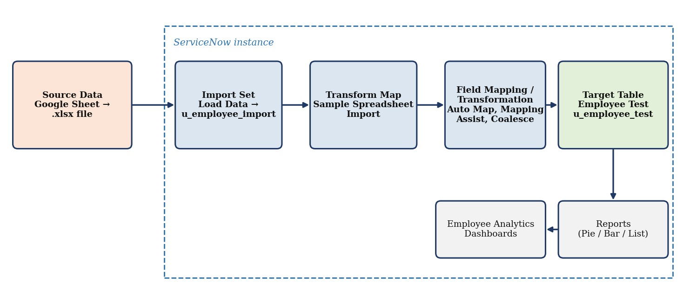
Figure 1: Architecture and data flow of Import Data Using Transform Maps
Architecture Description:
- Source Data: employee list prepared in Google Sheets and downloaded as Employee_proj.xlsx (15 records with Employee ID, Name, Email ID, Department, Location).
- Import Set: Load Data stages the spreadsheet rows in the Employee Import table (u_employee_import).
- Transform Map: “Sample Spreadsheet Import” links the Employee Import table to the target Employee Test table.
- Field Mapping / Transformation: source columns are mapped to target fields using Auto Map Matching Fields and Mapping Assist; Coalesce on Employee ID updates existing records and inserts only new ones.
- Target Table: Employee Test (u_employee_test) stores the final employee records; the transform history shows inserted, updated and ignored rows.
- Reports & Dashboard: three reports (Employees by Department, Employees by Location, Employee List) on Employee Test are added to the Employee Analytics Dashboards.

